Registration Form
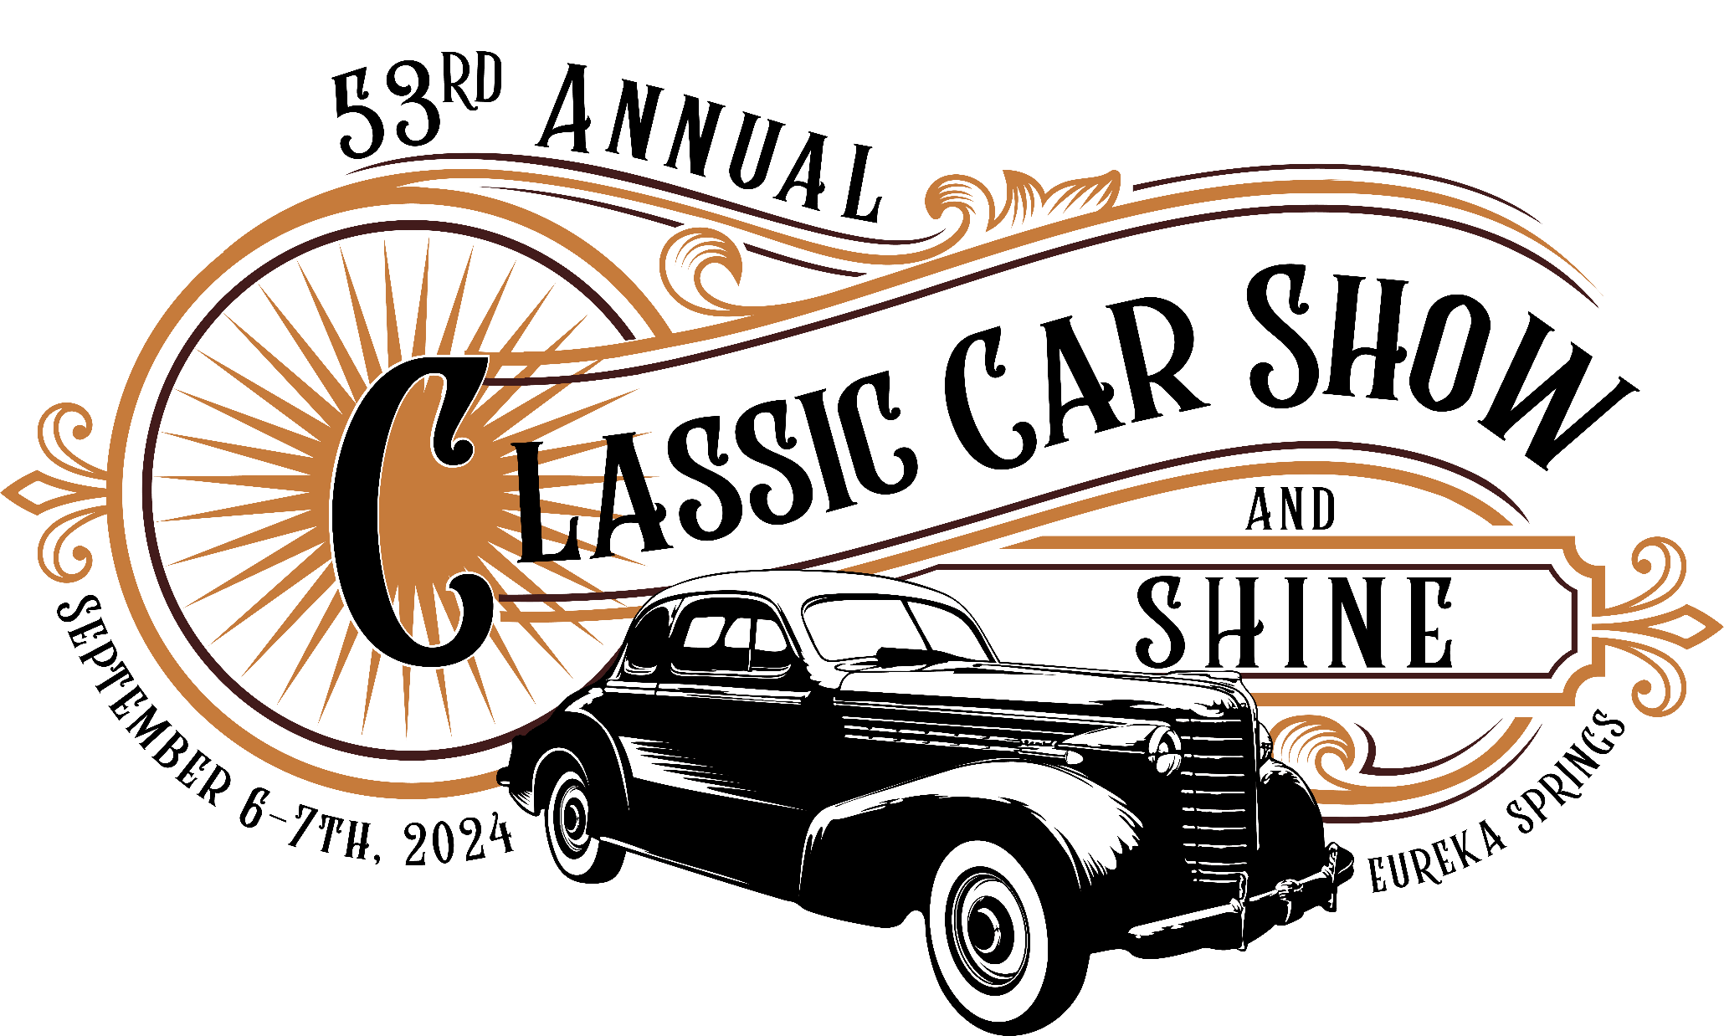

Pre-Registration is $25 to the First 150 Cars Thru July 31st -- $30 After July 31^{s}
Includes: The Friday Sunset Cruise to Beaver Lake Dam!
The Saturday Car Show w/Awards & Parade thru Historic Eureka Springs!
I’m Participating in: All of It _________ Friday Cruise_______ Saturday Car Show _________ Parade __________
Name ____________________________________
Address ____________________________________________________
City/State/Zip_______________________________________________
E-Mail ___________________________________________________
Phone _____________________
Vehicle Year _______ Make _________________ Model _______________
Car Club Affiliation ___________________________________________
Go To: Antiqueautofest.com Or Mail Checks Payable To:
Eureka Springs Chamber of Commerce
44 Kingshighway Suite A7,
Eureka Springs, AR 7263

